Spike: Spike 6
Title: Blocking Loop

Author: Rachel McQueenie 696737x

Goals / deliverables:
- Create a simple console program that implements the “Zorkish” game using a simple game loop which demonstrates the separation of input, update and render.

Technologies, Tools, and Resources used:
- Windows 7 / 8
- Visual Studio Professional 2012 / Ultimate 2012
- Spike 12

Tasks undertaken:
- Follow and complete Spike 12
- Add a bool variable to control whether the application is still looping or not
- Change all the Update() code to return a bool value instead of void. This includes Game and all the States.
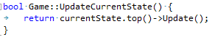
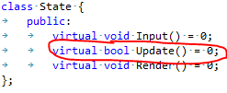
- Make sure all the Update() code returns true for whenever the game needs to continue running. In other words, only make it return false when exiting the application. The only time it should return false at this stage should be when the user inputs '5' (Quit) in the main menu.
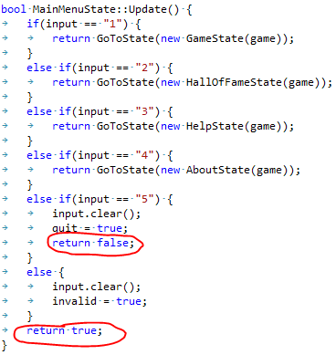
- Go back to your main function and wrap the Input, Update and Render in a while-loop. Make sure the condition for the while-loop is the bool from Step 2. Finally, set the bool variable to the returned value from Update. This ensures that the program continues to loop unless it has been exited.
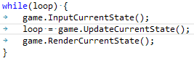
- Congratulations, you now have a Blocking Loop.
What we found out:
Even though the blocking game loop is the simplest implementation of the game loop concept, it is still viable in many contexts. Some games will require input from the player before anything further can happen, such as turn-based games like Chess, so in these situations it would add unnecessary complexity to run further updates around this.

This is also useful for some non-game applications, such as Word Processors.

